1. Which are the top three variables in your model which contribute most towards the probability of a lead getting converted?

**Answer:**

The top 3 variables that contribute most towards the probability of a lead getting converted are:

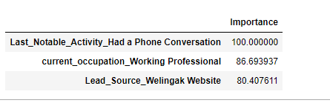

1. What are the top 3 categorical/dummy variables in the model which should be focused the most on in order to increase the probability of lead conversion?

**Answer:**

Following are the top 3 variables that should be focused most

* 1. Increase **Phone Conversation** with potential customers
  2. Target **Working Professional** clients and have phone conversation
  3. Invest more on marketing on **Welingak Website**

1. X Education has a period of 2 months every year during which they hire some interns. The sales team, in particular, has around 10 interns allotted to them. So during this phase, they wish to make the lead conversion more aggressive. So they want almost all of the potential leads (i.e. the customers who have been predicted as 1 by the model) to be converted and hence, want to make phone calls to as much of such people as possible. Suggest a good strategy they should employ at this stage.

**Answer:**

**Sensitivity** is the ratio of total number of actual conversions correctly predicted to the total no of actual conversions.

Similarly, **Specificity** is the ratio of total no of actual non-conversions correctly predicted to the total number of actual non-conversions.

When one increases the other decreases. Looking at the table below, when sensitivity decreases, the probability threshold and specificity increases. When the probability thresholds are very low, the sensitivity is very high and specificity is very low. Similarly, for larger probability thresholds, the sensitivity values are very low but the specificity values are very high.

The **sensitivity** of our model here is about 77. It shows the ratio of total number of actual conversions correctly predicted to the total number of conversions. This **sensitivity** rate is at probability threshold of 35 as seen in the following table.

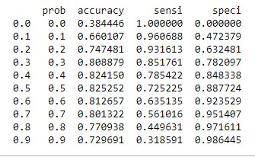

The value of sensitivity means how our model will correctly identify the leads who are likely to convert. The higher the better and It will decrease the chance of over-estimation of non-conversions to conversions of vis versa.

Since the X Education has plan to add more man-power for a period of 2 months and they wish to make the lead conversion more aggressive by wanting almost all of the potential leads, it is suggested they choose a lower threshold value to add more conversion by speeding up phone conversation as the phone conversation is one of the top 3 driving variable that adds most to the conversation.

1. Similarly, at times, the company reaches its target for a quarter before the deadline. During this time, the company wants the sales team to focus on some new work as well. So during this time, the company’s aim is to not make phone calls unless it’s extremely necessary, i.e. they want to minimize the rate of useless phone calls. Suggest a strategy they should employ at this stage.

**Answer:**

As answered in the above question, High sensitivity implies that our model will correctly identify almost all leads; at a suggested rate and threshold; who are likely to convert. So if the sensitivity at is that the rate of 72.5 it means that there will be this much chance that leads will actually convert and there is still a big chance of risky leads who will not convert.

Since X Education has already reached its target for a quarter and doesn’t want to make additional phone calls unless it’s extremely necessary, therefore it is recommended that they target leads with higher threshold and customers with higher lead score.

Higher threshold means higher specificity with lower sensitivity, that will make X Education sure to select almost all leads are most like to be converted.